**Oracle**

**Exam 1z0-808**

**Java SE 8 Programmer I**

**Version: 12.0**

# [ Total Questions: 144 ]

***Yanshu Gupta***



Oracle 1z0-808 : Practice Test

Given:

**Question No : 1**

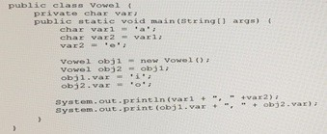

What is the result?

1. a, o i, o
2. a, o o, o
3. o, o i, o
4. o, o o, o

# Answer: a e

# o o

**Question No : 2**

Given the following class declarations: Which answer fails to compile?

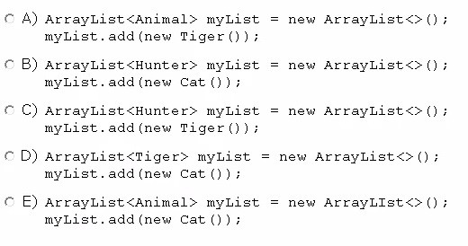



t

1. Option A
2. Option B
3. Option C
4. Option D
5. Option E

# Answer: E

**Question No : 3**

Given:

Oracle 1z0-808 : Practice Tes



t

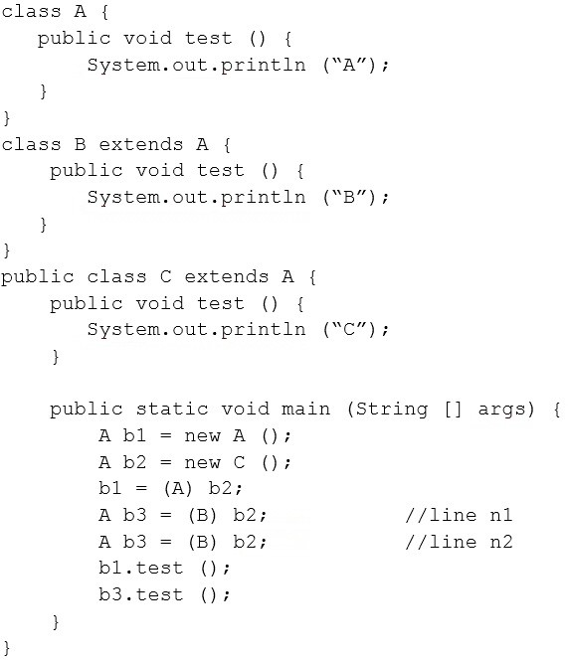

What is the result?

1. AB
2. AC
3. CC
4. A ClassCastException is thrown only at line n1.
5. A ClassCastException is thrown only at line n2.

# Answer: D

**Question No : 4**

Oracle 1z0-808 : Practice Tes Given:



t

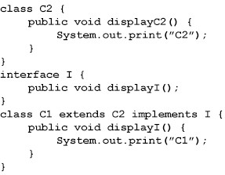

And given the code fragment:

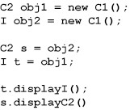

What is the result?

1. C2C2
2. C1C2
3. C1C1
4. Compilation fails

# Answer: D

**Type mismatch: cannot convert from I to C2**

# Type mismatch: cannot convert from C2 to I

**Question No : 5**

Oracle 1z0-808 : Practice Tes Given:



t

Acc.java:

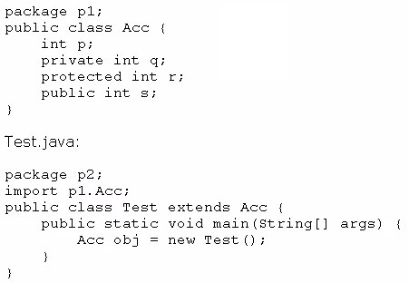

Which statement is true?

1. Both p and s are accessible by obj.
2. Only s is accessible by obj.
3. Both r and s are accessible by obj.
4. p, r, and s are accessible by obj.

# Answer: B

**Question No : 6**

Given:

Oracle 1z0-808 : Practice Tes



t

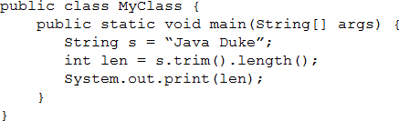

What is the result?

1. Compilation fails.
2. 11
3. 8
4. 9
5. 10

# Answer: D

**Question No : 7**

Given the code snippet from a compiled Java source file:

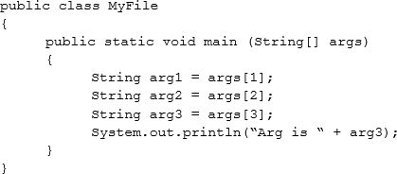

Which command-line arguments should you pass to the program to obtain the following output?

Arg is 2



t

**Question No : 8**

Oracle 1z0-808 : Practice Tes

1. java MyFile 1 3 2 2
2. java MyFile 2 2 2
3. java MyFile 1 2 2 3 4
4. java MyFile 0 1 2 3

# Answer: A

Given the code fragment:

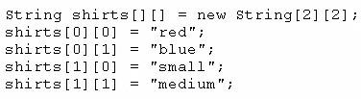

Which code fragment prints red: blue: small: medium?

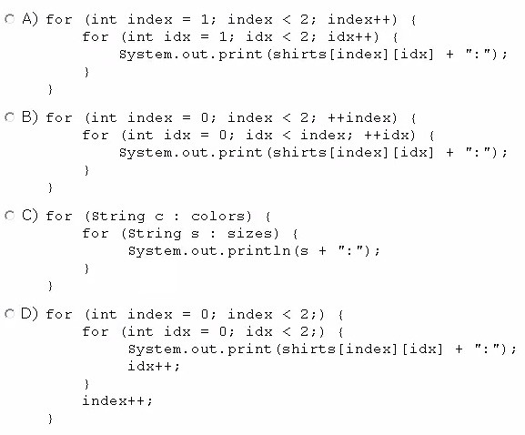



t

**Question No : 9**

Oracle 1z0-808 : Practice Tes

1. Option A
2. Option B
3. Option C
4. Option D

# Answer: D

Given the code fragment:

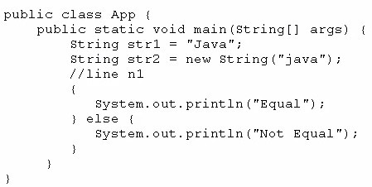

Which code fragment, when inserted at line n1, enables the App class to print Equal?

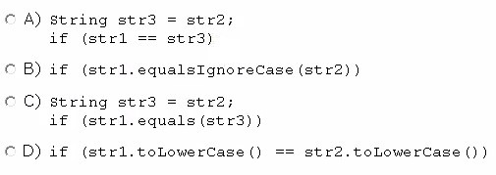

1. Option A
2. Option B
3. Option C
4. Option D



t

**Question No : 10**

Oracle 1z0-808 : Practice Tes

# Answer: B

Which three statements are true about exception handling?

1. Only unchecked exceptions can be rethrown.
2. All subclasses of the RuntimeException class are recoverable.
3. The parameter in a catch block is of Throwable type.
4. All subclasses of the RuntimeException class must be caught or declared to be thrown.
5. All subclasses of the Exception class except the RuntimeException class are checked exceptions.
6. All subclasses of the Error class are checked exceptions and are recoverable.

# Answer: B,C,E

**Question No : 11**

fragment:

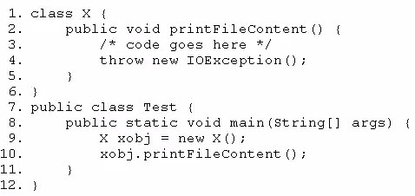

Which two modifications should you make so that the code compiles successfully?

Oracle 1z0-808 : Practice Tes



t

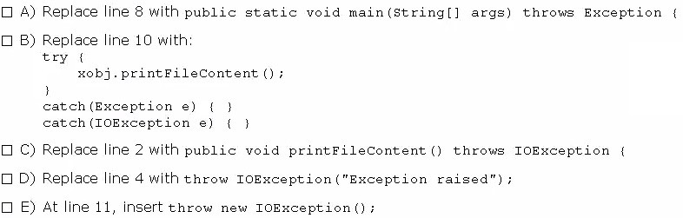

1. Option A
2. Option B
3. Option C
4. Option D
5. Option E

# Answer: A,C

**Question No : 12**

Given:

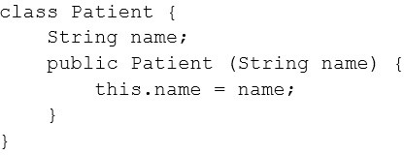

And the code fragment:

Oracle 1z0-808 : Practice Tes



t

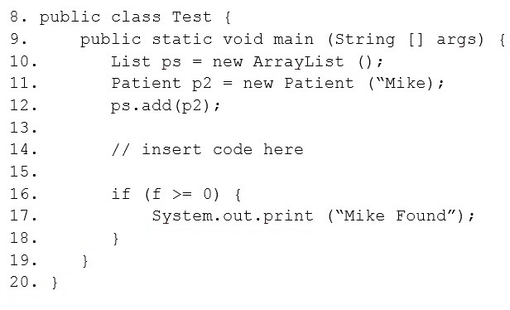

Which code fragment, when inserted at line 14, enables the code to print Mike Found?

1. int f = ps.indexOf (p2)
2. int f = ps.indexOf (Patient (“Mike”) );
3. int f = ps.indexOf (new Patient “Mike”) );
4. Patient p = new Patient (“Mike”);Int f = ps.indexOf (p)

# Answer: A

**Question No : 13**

Given the code fragment:

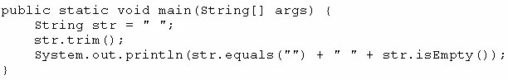

What is the result?

1. true true
2. true false
3. false false



t

**Question No : 14**

Oracle 1z0-808 : Practice Tes

1. false true

# Answer: C

Given the code fragment:

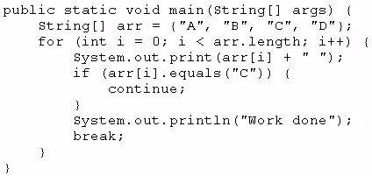

What is the result?

1. A B C Work done
2. A B C D Work done
3. A Work done
4. Compilation fails

# Answer: C

**Question No : 15**

Given:

Oracle 1z0-808 : Practice Tes



t

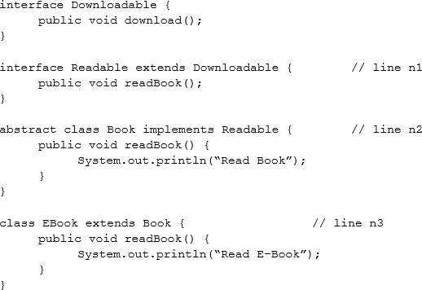

And given the code fragment:



What is the result?

1. Compilation fails at line n2.
2. Read Book
3. Read E-Book
4. Compilation fails at line n1.
5. Compilation fails at line n3.

# Answer: Compilation Failed---- E

# Class E-Book must implement all method

**Question No : 16**

Given:

Oracle 1z0-808 : Practice Tes



t

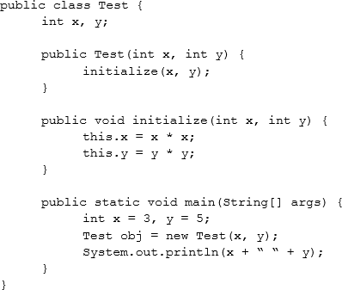

What is the result?

1. Compilation fails.
2. 3 5
3. 0 0

**D.** 9 25

# Answer: B

# We are not printing “obj.x” and “obj.y”

**Question No : 17**

Given:

Oracle 1z0-808 : Practice Tes



t

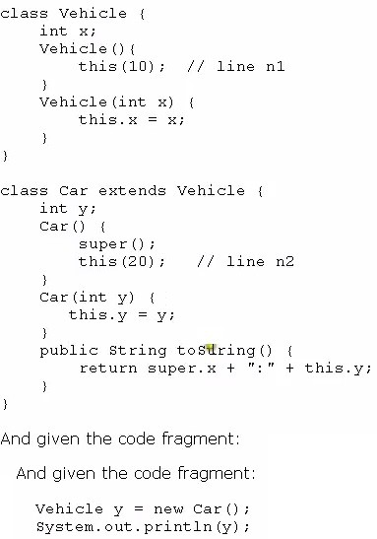

What is the result?

**A.** 10:20

**B.** 0:20

1. Compilation fails at line n1
2. Compilation fails at line n2

# Answer: D



Oracle 1z0-808 : Practice Test

The following grid shows the state of a 2D array:

**Question No : 18**

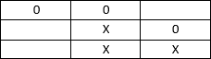

This grid is created with the following code:

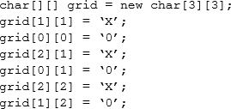

Which line of code, when inserted in place of //line n1, adds an X into the grid so that the grid contains three consecutive X’s?

**A.** grid[1][3] = ‘X’;

**B.** grid[3][1] = ‘X’;

**C.** grid[0][2] = ‘X’;

**D.** grid[2][0] = ‘X’;

**E.** grid[1][2] = ‘X’;

# Answer: D

**Question No : 19**

Given:

Oracle 1z0-808 : Practice Tes



t

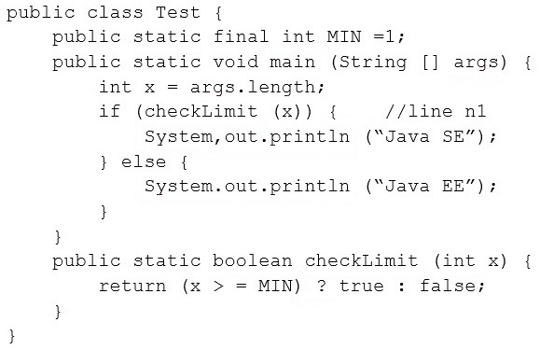

And given the commands: javac Test.java

java Test

What is the result?

1. Java SE
2. Java EE
3. Compilation fails at line n1.
4. A NullPointerException is thrown at runtime.

# Answer: B

**Question No : 20**

Given the code fragment:

Oracle 1z0-808 : Practice Tes



t

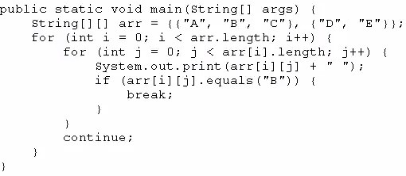

What is the result?

1. A B C
2. A B C D E
3. A B D E
4. Compilation fails.

# Answer: C

**Question No : 21**

Given:

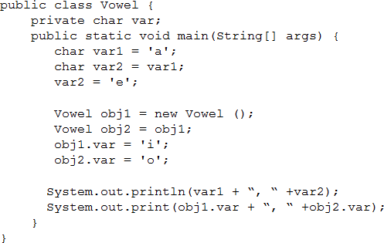



t

**Question No : 22**

Oracle 1z0-808 : Practice Tes What is the result?

1. e, ei, o
2. a, ei, o
3. a,eo, o
4. e, eo, o

# Answer: C

Given the code fragment:

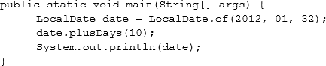

What is the result?

**A.** 2012-02-10

**B.** 2012-02-11

1. Compilation fails
2. A DateTimeException is thrown at runtime.

# Answer: D

**Question No : 23**

Given:

Oracle 1z0-808 : Practice Tes



t

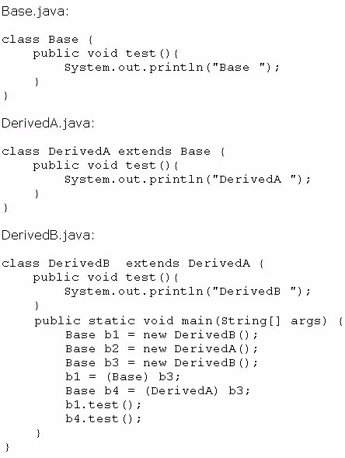

What is the result?

1. BaseDerivedA
2. BaseDerivedB
3. DerivedBDerivedB
4. DerivedBDerivedA
5. A classcast Exception is thrown at runtime.

# Answer: C



Oracle 1z0-808 : Practice Test

Which one of the following code examples uses valid Java syntax?

**Question No : 24**

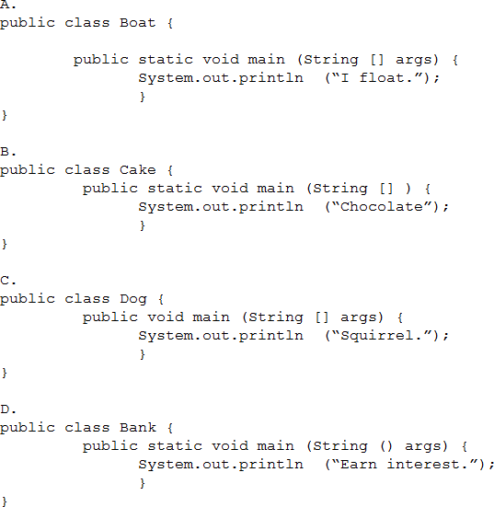

1. Option A
2. Option B
3. Option C
4. Option D

# Answer: A

**Explanation:** References:

**Question No : 25**

 Oracle 1z0-808 : Practice Test You are asked to develop a program for a shopping application, and you are given the following information:

Which definition of the Toy class adds a valid layer of abstraction to the class hierarchy?

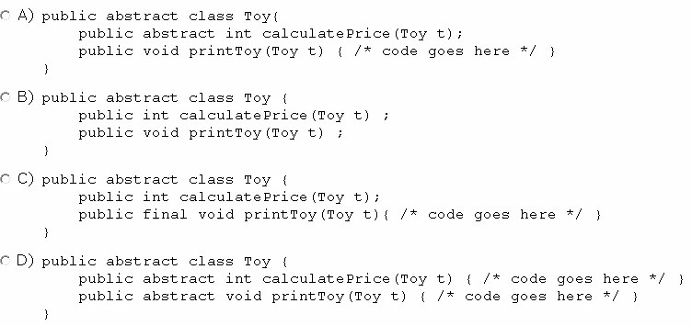

1. Option A
2. Option B
3. Option C
4. Option D

# Answer: A

**Question No : 26**

Given the code fragment:

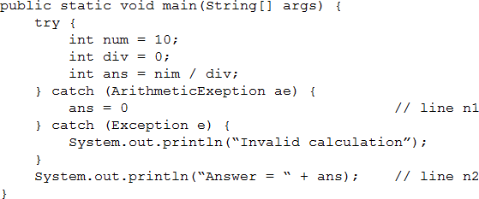

Oracle 1z0-808 : Practice Tes What is the result?



t

1. Answer = 0
2. Invalid calculation
3. Compilation fails only at line n1.
4. Compilation fails only at line n2.
5. Compilation fails only at line n1andline2.

# Answer: E

# Variables ans must be defined outside of the try block

**Question No : 27**

Given:



What is the result?

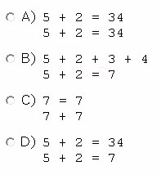

1. Option A
2. Option B
3. Option C
4. Option D

# Answer: D



t

**Question No : 28**

Oracle 1z0-808 : Practice Tes

Given the following two classes:

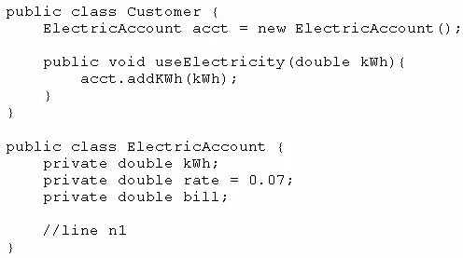

How should you write methods in the ElectricAccount class at line n1 so that the member variable bill is always equal to the value of the member variable kwh multiplied by the member variable rate?

Any amount of electricity used by a customer (represented by an instance of the customer class) must contribute to the customer's bill (represented by the member variable bill) through the method use Electricity method. An instance of the customer class should never be able to tamper with or decrease the value of the member variable bill.

Oracle 1z0-808 : Practice Tes



t

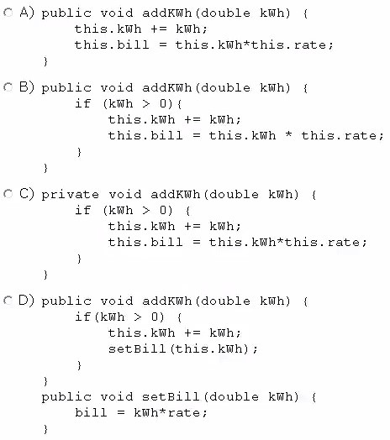

1. Option A
2. Option B
3. Option C
4. Option D

# Answer: A, B

**Question No : 29**

Given the code fragment:

Oracle 1z0-808 : Practice Tes



t

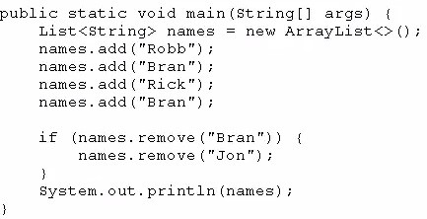

What is the result?

1. [Robb, Rick, Bran]
2. [Robb, Rick]
3. [Robb, Bran, Rick, Bran]
4. An exception is thrown at runtime.

# Answer: A

**Question No : 30**

Given:

Oracle 1z0-808 : Practice Tes



t

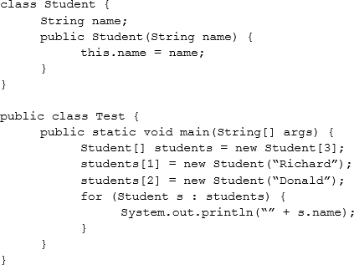

What is the result?

1. nullRichardDonald
2. RichardDonald
3. Compilation fails.
4. AnArrayIndexOutOfBoundsExceptionis thrown at runtime.
5. ANullPointerExceptionis thrown at runtime.

# Answer: E

**Question No : 31**

Given:

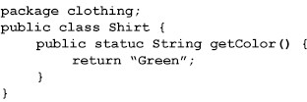

Oracle 1z0-808 : Practice Tes Given the code fragment:



t

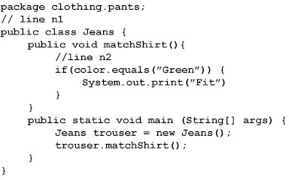

Which two sets of actions, independently, enable the code fragment to print Fit?

1. At line n1 insert:import clothing.Shirt;At line n2 insert:String color = getColor();
2. At line n1 insert:import clothing.*;At line n2 insert:String color = Shirt.getColor();
3. At line n1 insert:import static clothing.Shirt.getcolor;At line n2 insert:String color = getColor();
4. At line n1 no changes required.At line n2 insert:String color = Shirt.getColor();
5. At line n1 insert:import clothing;At line n2 insert:String color = Shirt.getColor();

# Answer: B, C

**Question No : 32**

Given:

Oracle 1z0-808 : Practice Tes



t

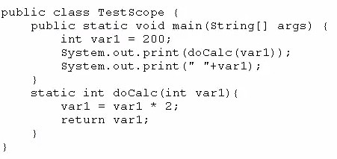

What is the result?

**A.** 400 200

**B.** 200 200

**C.** 400 400

**D.** Compilation fails.

# Answer: A

**Question No : 33**

Given:

Oracle 1z0-808 : Practice Tes



t

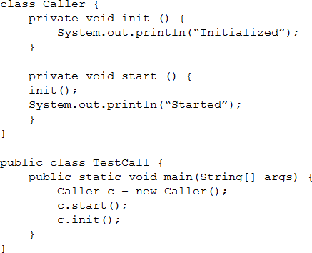

What is the result?

1. An exception is thrown at runtime.
2. Initialized Started Initialized
3. Initialized Started
4. Compilation fails.

# Answer: D

**Question No : 34**

Given the code fragment:

Oracle 1z0-808 : Practice Tes



t

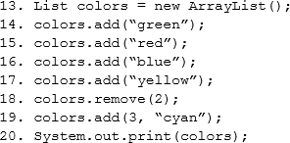

What is the result?

1. (green, red, yellow, cyan)
2. (green, blue, yellow, cyan)
3. (green, red, cyan, yellow)
4. AnIndexOutOfBoundsExceptionis thrown at runtime.

# Answer: A

**Question No : 35**

Which two are benefits of polymorphism?

1. Faster code at runtime
2. More efficient code at runtime
3. More dynamic code at runtime
4. More flexible and reusable code
5. Code that is protected from extension by other classes

**Answer: B, D**

**Explanation:** References:

**Question No : 36**

Given the code fragments:

Oracle 1z0-808 : Practice Tes



t

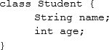

And,

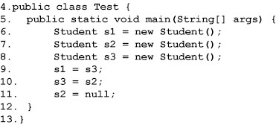

Which statement is true?

1. After line 11, three objects are eligible for garbage collection.
2. After line 11, two objects are eligible for garbage collection.
3. After line 11, one object is eligible for garbage collection.
4. After line 11, none of the objects are eligible for garbage collection.

# Answer: C

**Question No : 37**

Given the code fragment:

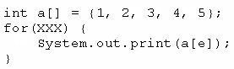



t

**Question No : 38**

Oracle 1z0-808 : Practice Tes Which option can replace xxx to enable the code to print 135?

**A.** int e = 0; e < = 4; e++

**B.** int e = 0; e < 5; e + = 2 **C.** int e = 1; e < = 5; e + = 1 **D.** int e = 1; e < 5; e+ =2

# Answer: B

Given the code fragment:

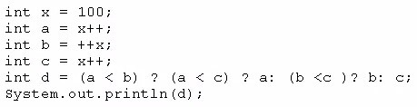

What is the result?

**A.** 100

**B.** 101

**C.** 102

**D.** 103

1. Compilation fails

# Answer: E

**Question No : 39**

Given the following class:

Oracle 1z0-808 : Practice Tes



t

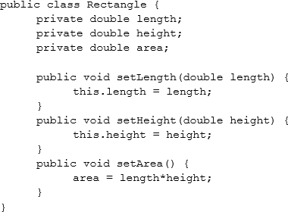

Which two changes would encapsulate this class and ensure that the area field is always equal to length * height whenever the Rectangle class is used?

1. Call the setArea method at the end of the setHeight method.
2. Call the setArea method at the beginning of the setHeight method.
3. Call the setArea method at the end of the setLength method.
4. Call the setArea method at the beginning of the setLength method.
5. Change the setArea method to private.
6. Change the area field to public.

# Answer: A, C

**Question No : 40**

Given the following class:

Oracle 1z0-808 : Practice Tes



t

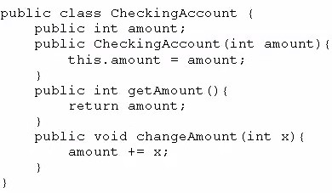

And given the following main method, located in another class:

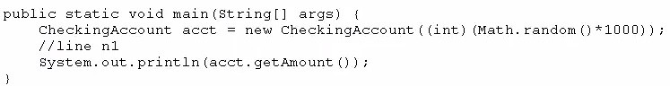

Which three lines, when inserted independently at line n1, cause the program to print a 0 balance?

1. this.amount = 0;
2. amount = 0;
3. acct (0) ;
4. acct.amount = 0;
5. acct. getAmount () = 0;
6. acct.changeAmount(0);
7. acct.changeAmount(-acct.amount);
8. acct.changeAmount(-acct.getAmount());

# Answer: D, G, H

**Question No : 41**

Given:

Oracle 1z0-808 : Practice Tes



t

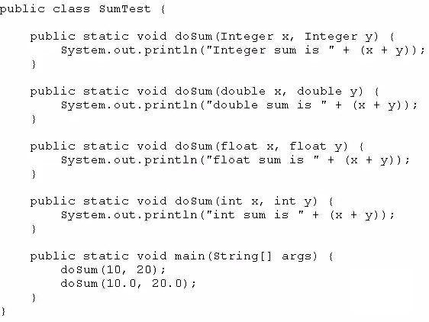

What is the result?

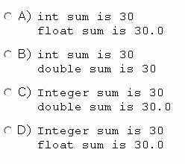

1. Option A
2. Option B
3. Option C
4. Option D

# Answer: B



Oracle 1z0-808 : Practice Test

Given:

**Question No : 42**

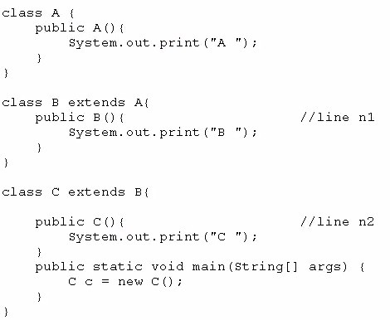

What is the result?

1. C B A
2. C
3. A B C
4. Compilation fails at line n1 and line n2

# Answer: C

**Question No : 43**

Given the code fragment:

Oracle 1z0-808 : Practice Tes



t

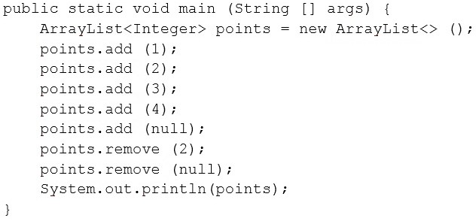

What is the result?

**A.** A NullPointerException is thrown at runtime.

**B.** [1, 2, 4]

**C.** [1, 2, 4, null ]

**D.** [1, 3, 4, null ]

**E.** [1, 3, 4 ]

**F.** Compilation fails.

# Answer: B

**Question No : 44**

Given:

Oracle 1z0-808 : Practice Tes



t

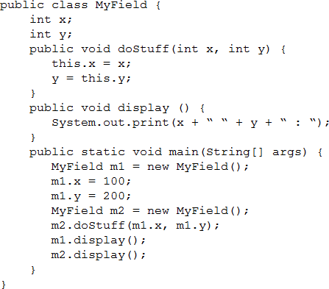

What is the result?

**A.** 100 0 : 100 200:

**B.** 100 0 : 100 0 :

**C.** 100 200 : 100 200 :

**D.** 100 200 : 100 0 :

# Answer: D

**Question No : 45**

Given:

Class Test{

int a1;

public static void doProduct(int a) {

a = a * a;

}

public static void doString(StringBuilder s) { s.append(“ “ + s);

}

public static void main(String[] args) { Test item = new Test();

item.a1 = 11;

StringBuilder sb = new StringBuilder(“Hello”);

Integer i = 10;

doProduct(i); doString(sb); doProduct(item.a1);

System.out.println(i + “ “ + sb + “ “ + item.a1);

}

}

What is the result?

1. 10 Hello Hello 11
2. 10 Hello Hello 121
3. 100 Hello 121
4. 100 Hello Hello 121
5. 10 Hello 11

# Answer: A

**Question No : 46**

Oracle 1z0-808 : Practice Tes Given:



t

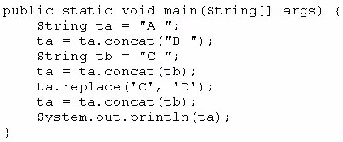

What is the result?

1. A B C D
2. A C D
3. A B C C
4. A B D
5. A B D C

# Answer: C

**Question No : 47**

Given the code fragment:

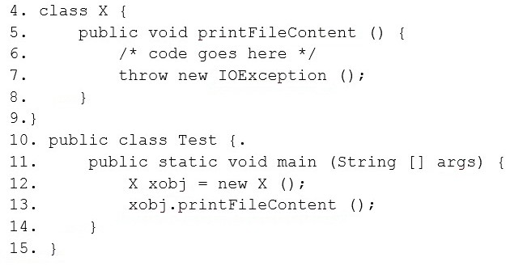

Oracle 1z0-808 : Practice Tes



t

Which two modifications should you make so that the code compiles successfully?

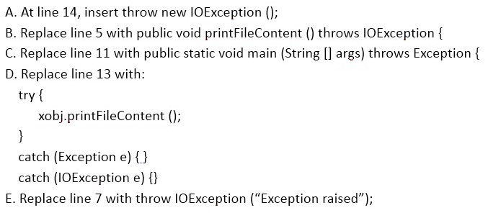

1. Option A
2. Option B
3. Option C
4. Option D
5. Option E

# Answer: B, C

**Question No : 48**

Given the code fragment:

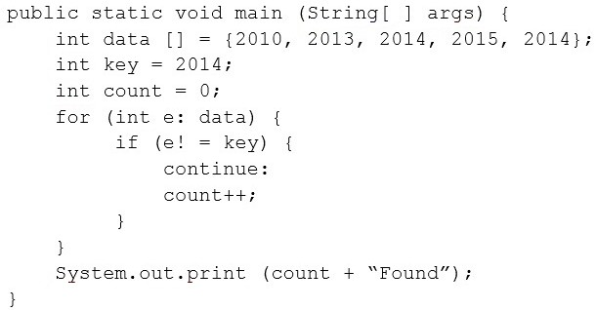



t

**Question No : 49**

Oracle 1z0-808 : Practice Tes What is the result?

1. Compilation fails.
2. 0 Found
3. 1 Found
4. 3 Found

# Answer: A

Given the code fragment:

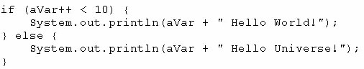

What is the result if the integer aVar is 9?

1. 10 Hello World!
2. Hello Universe!
3. Hello World!
4. Compilation fails.

# Answer: A

**Question No : 50**

Given the code fragment from three files:

Oracle 1z0-808 : Practice Tes



t

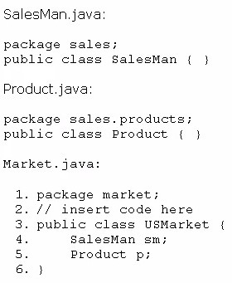

Which code fragment, when inserted at line 2, enables the code to compile?

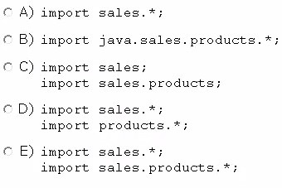

1. Option A
2. Option B
3. Option C
4. Option D



t

**Question No : 51**

Oracle 1z0-808 : Practice Tes

1. Option E

# Answer: E

Given the code fragment:

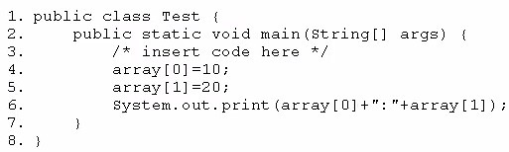

Which code fragment, when inserted at line 3, enables the code to print 10:20?

1. int[] array n= new int[2];
2. int[] array;array = int[2];
3. int []array = new int[2];
4. int array [2] ;

# Answer: C

**Question No : 52**

Which two class definitions fail to compile?

1. abstract class A3 {private static int i;public void doStuff(){}public A3(){}}
2. final class A1 {public A1(){}}
3. public class A2 {private static int i;private A2(){}}
4. class A4 {protected static final int i;private void doStuff(){}}
5. final abstract class A5 {protected static int i;void doStuff(){}abstract void doIt();}

# Answer: D,E



Oracle 1z0-808 : Practice Test

Given the code fragments:

**Question No : 53**

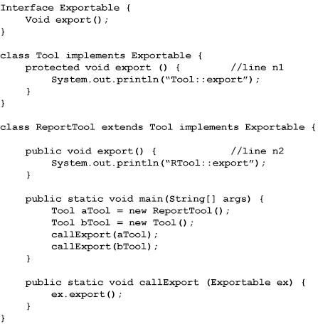

What is the result?

1. Compilation fails only at line n2.
2. RTool::exportTool::export
3. Tool::exportTool:export
4. Compilation fails only at line n1.
5. Compilation fails at both line n1 and line n2.

# Answer: D



Oracle 1z0-808 : Practice Test

Given the code fragment:

What is the result?

**Question No : 54**



1. An exception is thrown at runtime.
2. Compilation fails.

**C.** 13480.0

**D.** 13480.02

# Answer: C

**Question No : 55**

Given the code fragment:

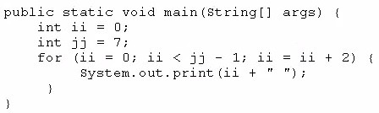

What is the result?

**A.** 2 4

**B.** 0 2 4 6

**C.** 0 2 4

**D.** Compilation fails

# Answer: C



Oracle 1z0-808 : Practice Test

Given the code fragment:

**Question No : 56**

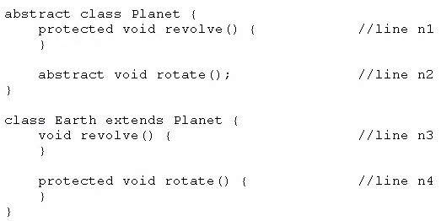

Which two modifications, made independently, enable the code to compile?

1. Make the method at line n1 public.
2. Make the method at line n2 public.
3. Make the method at line n3 public.
4. Make the method at line n3 protected.
5. Make the method at line n4 public.

# Answer: C or D

**Question No : 57**

You are asked to create a method that accepts an array of integers and returns the highest value from that array.

Given the code fragment:

Oracle 1z0-808 : Practice Tes



t

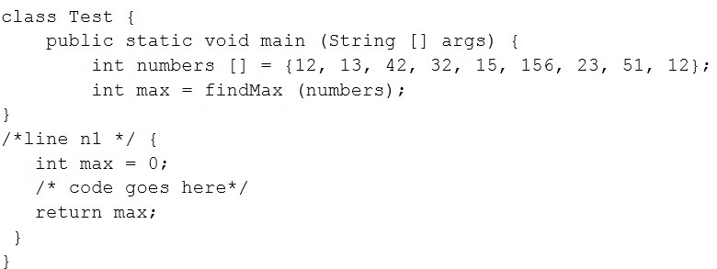

Which method signature do you use at line n1?

1. public int findMax (int [] numbers)
2. static int[] findMax (int max)
3. static int findMax (int [] numbers)
4. final int findMax (int [] )

# Answer: C

**Question No : 58**

Given the following class:

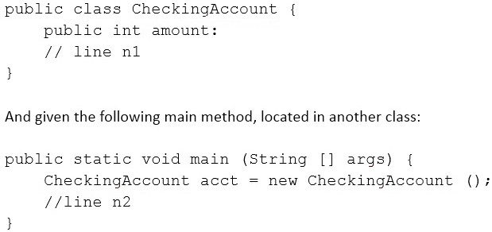

Which three pieces of code, when inserted independently, set the value of amount to 100?

Oracle 1z0-808 : Practice Tes



t

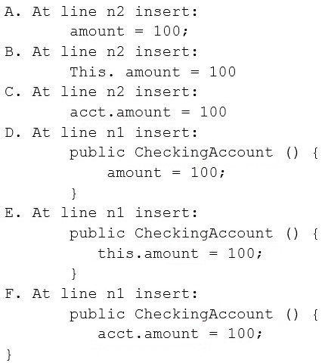

1. Option A
2. Option B
3. Option C
4. Option D
5. Option E
6. Option F

# Answer: C, D, E

**Question No : 59**

Given:

Oracle 1z0-808 : Practice Tes



t

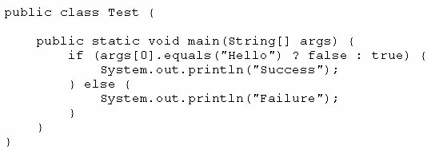

And given the commands: javac Test.Java

Java Test Hello What is the result?

1. Success
2. Failure
3. Compilation fails.
4. An exception is thrown at runtime

# Answer: B

**Question No : 60**

Given:

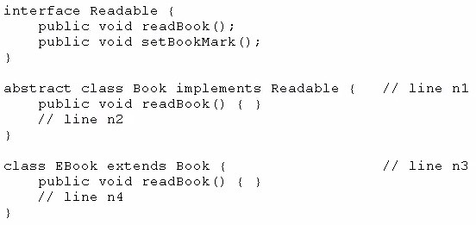

Oracle 1z0-808 : Practice Tes Which option enables the code to compile?



t

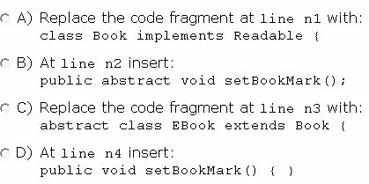

1. Option A
2. Option B
3. Option C
4. Option D

# Answer: C/D

**Question No : 61**

Which statement is true about Java byte code?

1. It can run on any platform.
2. It can run on any platform only if it was compiled for that platform.
3. It can run on any platform that has the Java Runtime Environment.
4. It can run on any platform that has a Java compiler.
5. It can run on any platform only if that platform has both the Java Runtime Environment and a Java compiler.

# Answer: D

**Explanation:** References:

**Question No : 62**

Oracle 1z0-808 : Practice Tes Given:



t

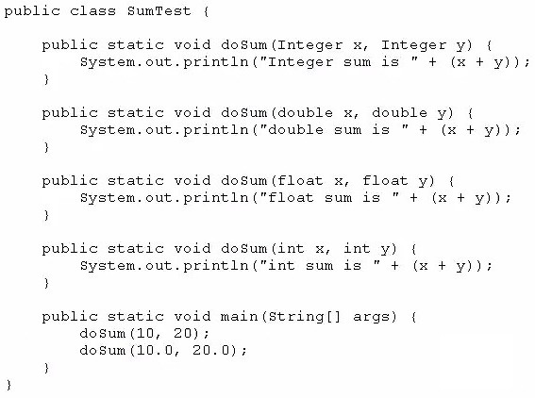

What is the result?

1. int sum is 30float sum is 30.0
2. int sum is 30double sum is30.0
3. integer sum is 30double sum is 30.0
4. integer sum is 30float sum is 30.0

# Answer: B

**Question No : 63**

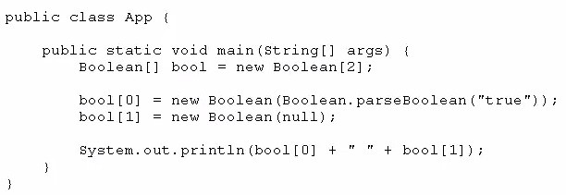Given:



t

**Question No : 64**

Oracle 1z0-808 : Practice Tes What is the result?

1. True false
2. True null
3. Compilation fails
4. A NullPointerException is thrown at runtime

# Answer: A

Given:

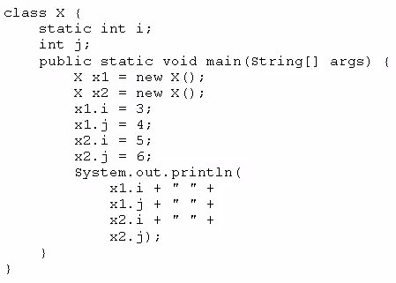

What is the result?

**A.** 3 4 5 6

**B.** 3 4 3 6

**C.** 5 4 5 6

**D.** 3 6 4 6

# Answer: C



Oracle 1z0-808 : Practice Test

Which three statements describe the object-oriented features of the Java language?

1. Objects cannot be reused.
2. A subclass can inherit from a superclass.
3. Objects can share behaviors with other objects.
4. A package must contain more than one class.
5. Object is the root class of all other objects.
6. A main method must be declared in every class.

**Question No : 65**

**Answer: B, C, E Explanation:** References:

**Question No : 66**

Given the following code:

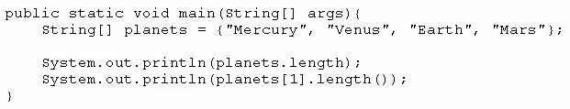

What is the output?

1. 44
2. 35
3. 47
4. 54
5. 45

**F.** 421

# Answer: E

**Question No : 67**

Given the following code for a Planet object:

Oracle 1z0-808 : Practice Tes



t

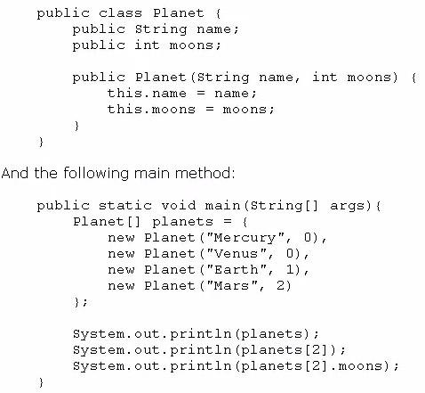

What is the output?

Oracle 1z0-808 : Practice Tes



t

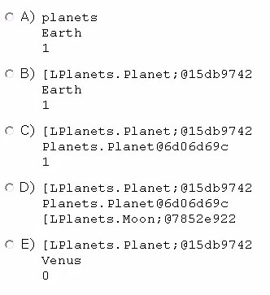

1. Option A
2. Option B
3. Option C
4. Option D
5. Option E

# Answer: C

**Question No : 68**

Given:

Oracle 1z0-808 : Practice Tes



t

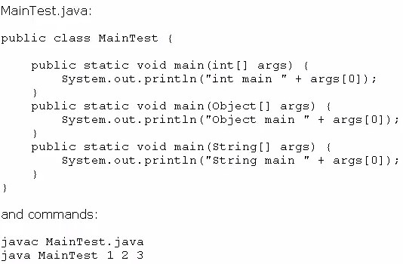

What is the result?

1. int main 1
2. Object main 1
3. String main 1
4. Compilation fails
5. An exception is thrown at runtime

# Answer: C

**Question No : 69**

Given:

Oracle 1z0-808 : Practice Tes



t

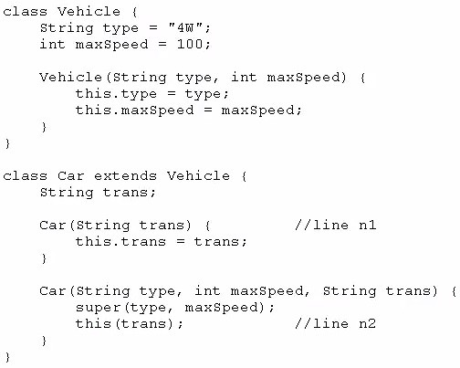

And given the code fragment:

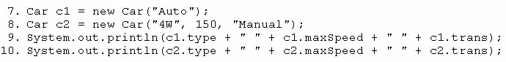

What is the result?

1. 4W 100 Auto4W 150 Manual
2. Null 0 Auto4W 150 Manual
3. Compilation fails only at line n1
4. Compilation fails only at line n2
5. Compilation fails at both line n1 and line n2

# Answer: E

**Question No : 70**

Given the code fragment:

Oracle 1z0-808 : Practice Tes int[] array = {1, 2, 3, 4, 5};



t

And given the requirements:

* 1. Process all the elements of the array in the order of entry.
  2. Process all the elements of the array in the reverse order of entry.
  3. Process alternating elements of the array in the order of entry.

Which two statements are true?

* + 1. Requirements 1, 2, and 3 can be implemented by using the enhanced for loop.
    2. Requirements 1, 2, and 3 can be implemented by using the standard for loop.
    3. Requirements 2 and 3 CANNOT be implemented by using the standard for loop.
    4. Requirement 1 can be implemented by using the enhanced for loop.
    5. Requirement 3 CANNOT be implemented by using either the enhanced for loop or the standard for loop.

# Answer: B,D

**Question No : 71**

Given:

Oracle 1z0-808 : Practice Tes



t

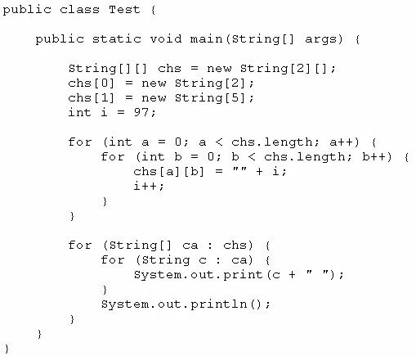

What is the result?

**A.** 97 98 99 100 null null null

**B.** 97 98 99 100 101 102 103

1. Compilation rails.
2. A NullPointerException is thrown at runtime.
3. An ArraylndexOutOfBoundsException is thrown at runtime.

# Answer: A

**Question No : 72**

Given the code fragment:

Oracle 1z0-808 : Practice Tes



t

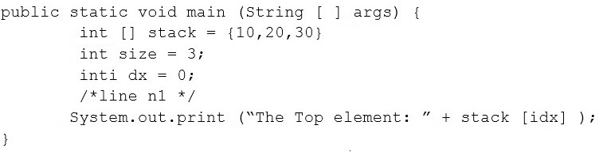

Which code fragment, inserted at line n1, pints The Top element: 30?

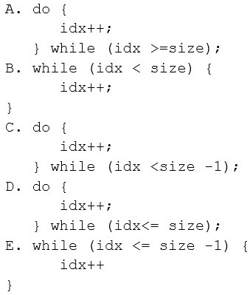

1. Option A
2. Option B
3. Option C
4. Option D
5. Option E



t

**Question No : 73**

Oracle 1z0-808 : Practice Tes

# Answer: C

Given the following classes:

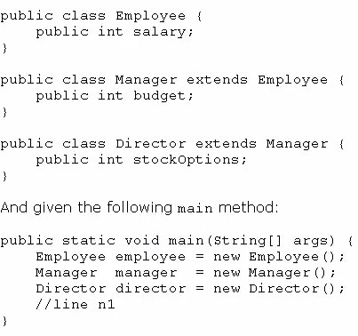

Which two options fail to compile when placed at line n1 of the main method?

1. employee.salary = 50_000;
2. director.salary = 80_000;
3. employee.budget = 200_000;
4. manager.budget = 1_000_000;
5. manager.stockOption = 500;
6. director.stockOptions = 1_000;

# Answer: C,E



Oracle 1z0-808 : Practice Test

Given the code fragment:

**Question No : 74**

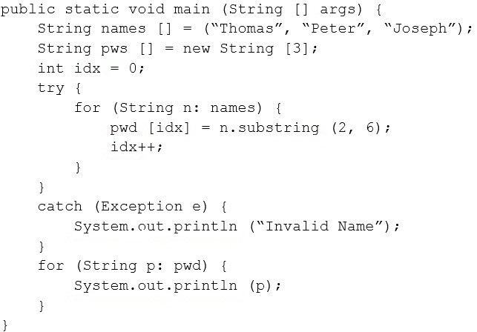

What is the result?

1. Invalid Name
2. Invalid Nameomas
3. Invalid Name omas null null
4. omasterseph

# Answer: C

**Question No : 75**

Given the following main method:

Oracle 1z0-808 : Practice Tes



t

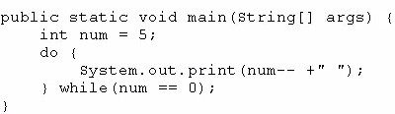

What is the result?

**A.** 5 4 3 2 1 0

**B.** 5 4 3 2 1

**C.** 4 2 1

1. 5
2. Nothing is printed

# Answer: D

**Question No : 76**

Given:

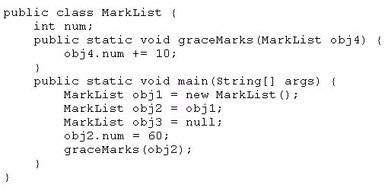

How many MarkList instances are created in memory at runtime?

1. 1
2. 2
3. 3



t

**Question No : 77**

Oracle 1z0-808 : Practice Tes

1. 4

# Answer: A

Given:

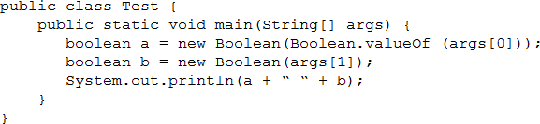

And given the commands: javac Test.java

java Test TRUE null What is the result?

1. TRUE null
2. true false
3. false false
4. true true
5. AClassCastExceptionis thrown at runtime.

# Answer: B

**Question No : 78**

You are developing a banking module. You have developed a class named ccMask that has a maskcc method.

Given the code fragment:

 Oracle 1z0-808 : Practice Test

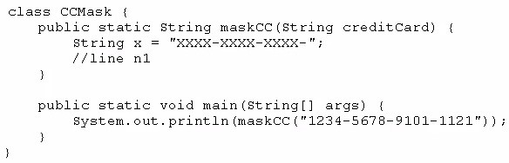

You must ensure that the maskcc method returns a string that hides all digits of the credit card number except the four last digits (and the hyphens that separate each group of four digits).

Which two code fragments should you use at line n1, independently, to achieve this requirement?

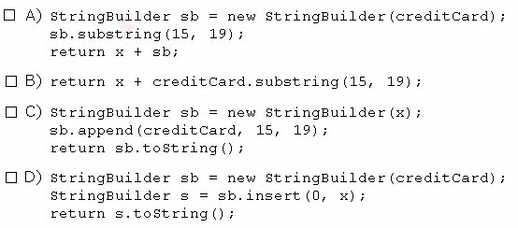

1. Option A
2. Option B
3. Option C
4. Option D

# Answer: B,C

**Question No : 79**

Given:

Oracle 1z0-808 : Practice Tes



t

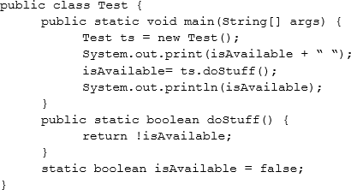

What is the result?

1. Compilation fails.
2. false true
3. true false
4. true true
5. false false

# Answer: B

**Question No : 80**

Given the code fragment:

Oracle 1z0-808 : Practice Tes



t

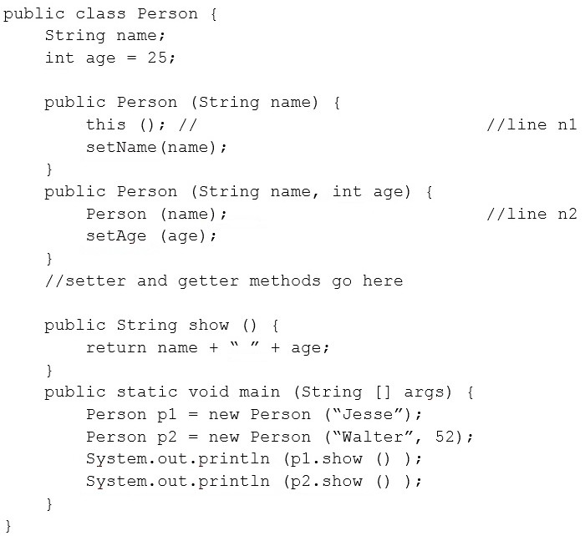

What is the result?

1. Compilation fails at both line n1 and line n2.
2. Compilation fails only at line n2.
3. Compilation fails only at line n1.
4. Jesse 25Walter 52

# Answer: A

# n1 – no args constructor not defined

# n2 – Invalid method call, Person is not a method it is constructor

**Question No : 81**

Given:

Oracle 1z0-808 : Practice Tes



t

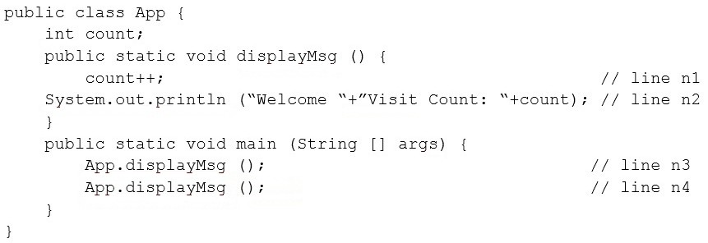

What is the result?

1. Compilation fails at line n3 and line n4.
2. Compilation fails at line n1 and line n2.
3. Welcome Visit Count:1Welcome Visit Count: 2
4. Welcome Visit Count:1Welcome Visit Count: 2

# Answer: B

**Question No : 82**

Given:

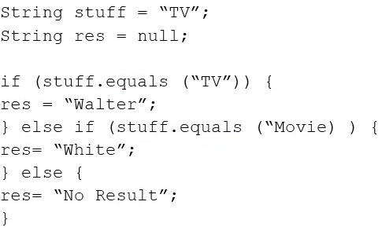

Which code fragment can replace the if block?

 Oracle 1z0-808 : Practice Test

1. stuff.equals (“TV”) ? res= “Walter” : stuff.equals (“Movie”) ? res = “White” : res = “No Result”;
2. res = stuff.equals (“TV”) ? “Walter” else stuff.equals (“Movie”)? “White” : “No Result”;
3. res = stuff.equals (“TV”) ? stuff.equals (“Movie”)? “Walter” : “White” : “No Result”;
4. res = stuff.equals (“TV”)? “Walter” : stuff.equals (“Movie”)? “White” : “No Result”;

# Answer: D

**Question No : 83**

Given the code fragment:

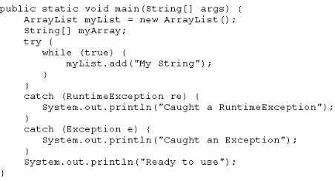

What is the result?

1. Execution terminates in the first catch statement, and caught a RuntimeException is printed to the console.
2. Execution terminates in the second catch statement, and caught an Exception is printed to the console.
3. A runtime error is thrown in the thread "main".
4. Execution completes normally, and Ready to use is printed to the console.
5. The code fails to compile because a throws keyword is required.

# Answer: C

**Question No : 84**

Oracle 1z0-808 : Practice Tes Given:



t

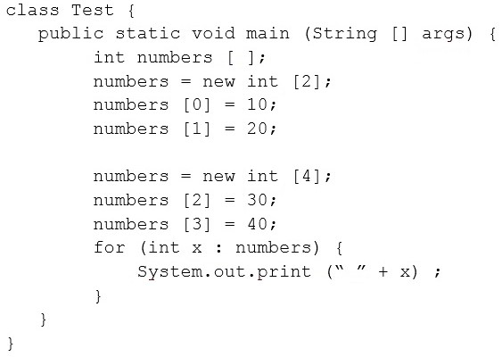

What is the result?

**A.** 10 20 30 40

**B.** 0 0 30 40

1. Compilation fails.
2. An exception is thrown at runtime.

# Answer: B

**Question No : 85**

Given the code fragments:

Oracle 1z0-808 : Practice Tes



t

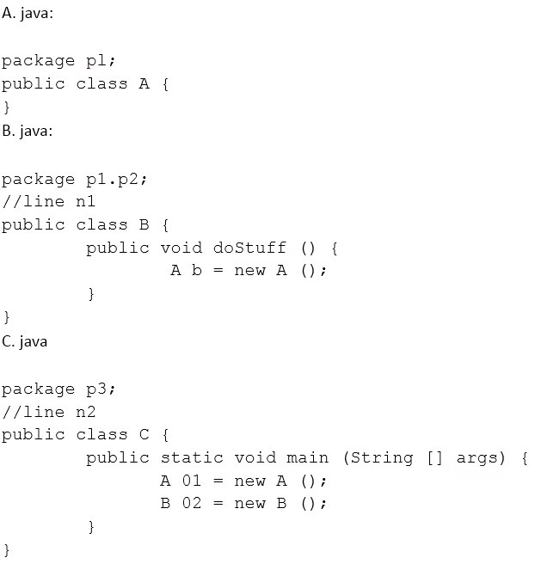

Which modification enables the code to compile?

1. Replace line n1 with:import p1.*;Replace line n2 with:import p1. p2.*;
2. Replace line n1 with:import p1. A;Replace line n2 with:import p1.*;
3. Replace line n1 with:import p1. A;Replace line n2 with:import p1. A;import p1. p2.B ;
4. Replace line n1 with:import p1;Replace line n2 with:import p1;import p1. p2;

# Answer: C

**Question No : 86**

Given:

Oracle 1z0-808 : Practice Tes



t

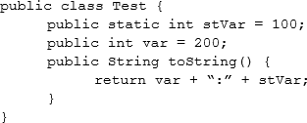

And given the code fragment:

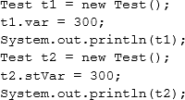

What is the result?

**A.** 300:300200:300

**B.** 300:100200:300

**C.** 300:00:300

**D.** 200:300200:300

# Answer: B

**Question No : 87**

Given the code fragment:

Oracle 1z0-808 : Practice Tes



t

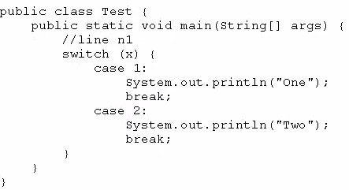

Which three code fragments can be independently inserted at line n1 to enable the code to print one?

1. Byte x = 1;
2. short x = 1;
3. String x = "1";
4. Long x = 1;
5. Double x = 1;
6. Integer x = new Integer ("1");

# Answer: A,B,F

**Question No : 88**

Given the code from the Greeting.Java file:

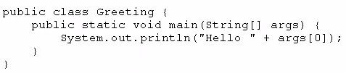

Which set of commands prints Hello Duke in the console?

Oracle 1z0-808 : Practice Tes



t

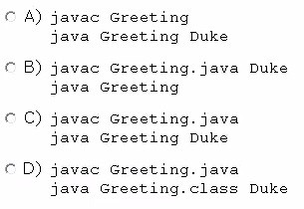

1. Option A
2. Option B
3. Option C
4. Option D

# Answer: C

**Question No : 89**

Given:

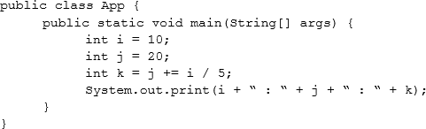

What is the result?

**A.** 10 : 30 : 6

**B.** 10 : 22 : 22

**C.** 10 : 22 : 20

**D.** 10 : 22 : 6

Oracle 1z0-808 : Practice Tes



t

**Answer: B Explanation:** Explanation

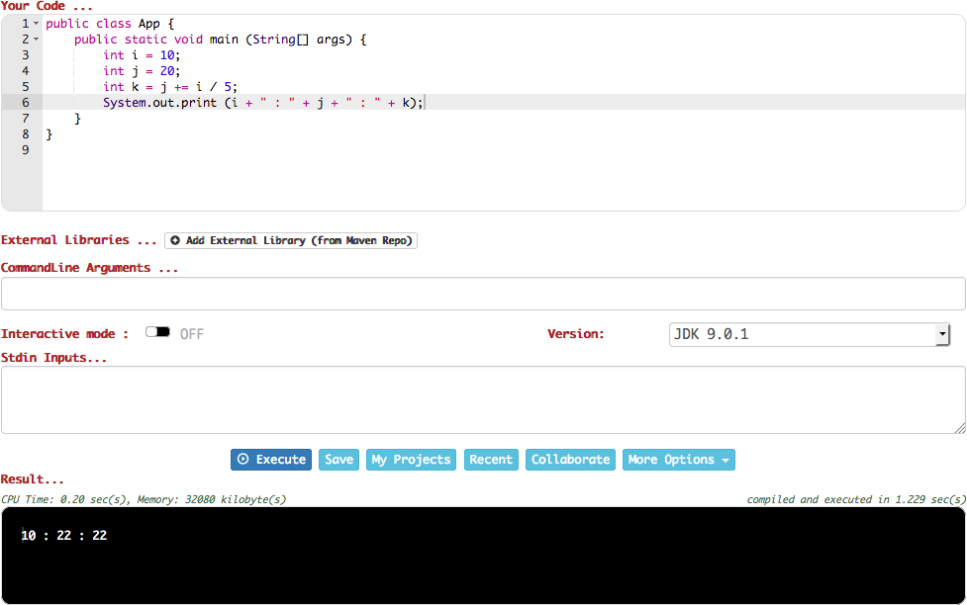

**Question No : 90**

Given the code fragment:

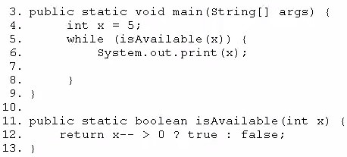



t

**Question No : 91**

Oracle 1z0-808 : Practice Tes Which modification enables the code to print 54321?

1. Replace line 6 with System, out. print (--x) ;
2. At line7, insert x --;
3. Replace line 6 with --x; and, at line 7, insert system, out. print (x);
4. Replace line 12 With return (x > 0) ? false: true;

# Answer: B

Given the code fragment:

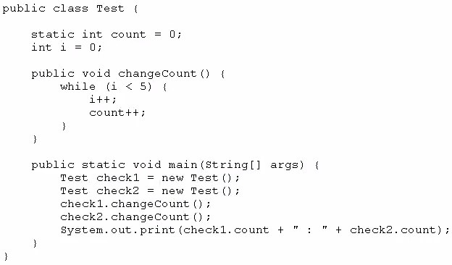

What is the result?

**A.** 10 : 10

**B.** 5 : 5

**C.** 5 : 10

**D.** Compilation fails

# Answer: A

**Question No : 92**

Oracle 1z0-808 : Practice Tes Given the code fragment:



t

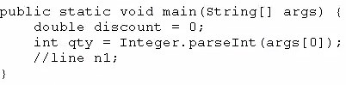

And given the requirements:

Which two code fragments can be independently placed at line n1 to meet the requirements?

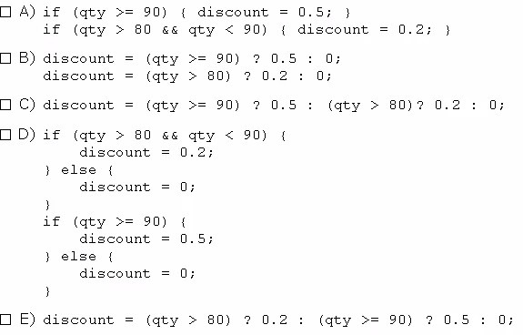

1. Option A
2. Option B
3. Option C
4. Option D
5. Option E

# Answer: A,C

**Question No : 93**

Oracle 1z0-808 : Practice Tes Given the following code:



t

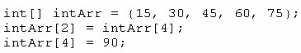

What are the values of each element in intArr after this code has executed?

**A.** 15, 60, 45, 90, 75

**B.** 15, 90, 45, 90, 75

**C.** 15, 30, 75, 60, 90

**D.** 15, 30, 90, 60, 90

**E.** 15, 4, 45, 60, 90

# Answer: C

**Question No : 94**

Given the following array:



Which two code fragments, independently, print each element in this array?

Oracle 1z0-808 : Practice Tes



t

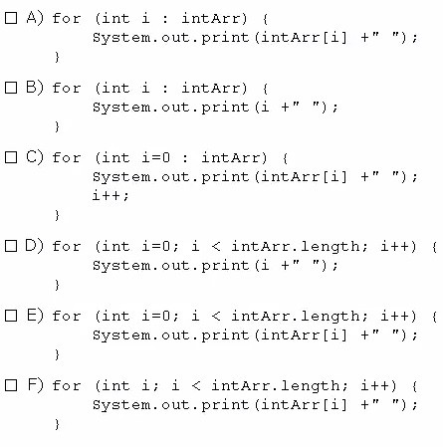

1. Option A
2. Option B
3. Option C
4. Option D
5. Option E
6. Option F

# Answer: B,E

**Question No : 95**

Given the code fragment:

Oracle 1z0-808 : Practice Tes



t

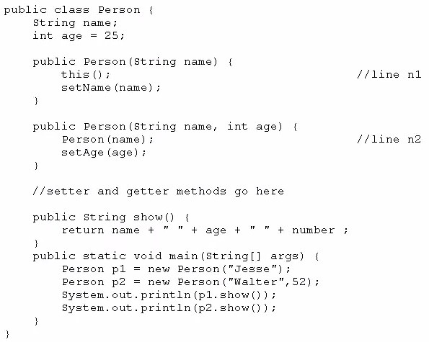

What is the result?

1. Jesse 25Walter 52
2. Compilation fails only at line n1
3. Compilation fails only at line n2
4. Compilation fails at both line n1 and line n2

# Answer: D

**Question No : 96**

Given the code fragments:

Oracle 1z0-808 : Practice Tes



t

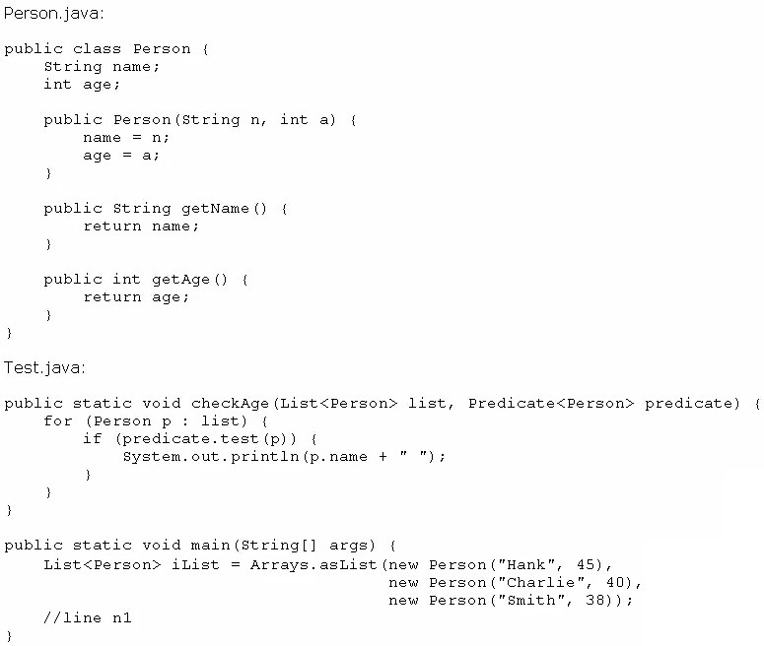

Which code fragment, when inserted at line n1, enables the code to print Hank?

1. checkAge (iList, ( ) -> p. get Age ( ) > 40);
2. checkAge(iList, Person p -> p.getAge( ) > 40);
3. checkAge (iList, p -> p.getAge ( ) > 40);
4. checkAge(iList, (Person p) -> { p.getAge() > 40; });

# Answer: C

**Question No : 97**

Given:

Oracle 1z0-808 : Practice Tes



t

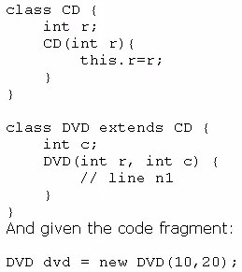

Which code fragment should you use at line n1 to instantiate the dvd object successfully?

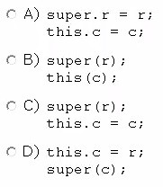

1. Option A
2. Option B
3. Option C
4. Option D

# Answer: C



t

**Question No : 98**

Oracle 1z0-808 : Practice Tes

Given:

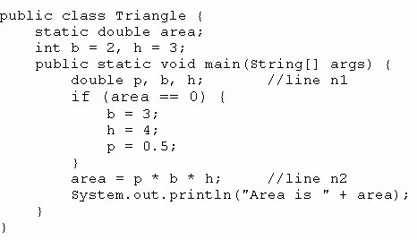

What is the result?

1. Area is 6.0
2. Area is 3.0
3. Compilation fails at line n1
4. Compilation fails at line n2.

# Answer: D

**Question No : 99**

Which statement best describes encapsulation?

1. Encapsulation ensures that classes can be designed so that only certain fields and methods of an object are accessible from other objects.
2. Encapsulation ensures that classes can be designed so that their methods are inheritable.
3. Encapsulation ensures that classes can be designed with some fields and methods declared as abstract.



t

**Question No : 100**

Oracle 1z0-808 : Practice Tes

1. Encapsulation ensures that classes can be designed so that if a method has an argument MyType x, any subclass of MyType can be passed to that method.

# Answer: A

Given the definitions of the MyString class and the Test class:

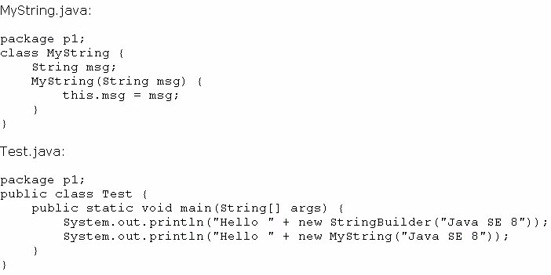

What is the result?

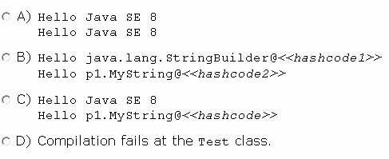

1. Option A
2. Option B
3. Option C
4. Option D

**Answer: C**



t

**Question No : 101**

Oracle 1z0-808 : Practice Tes

Given the code fragment:

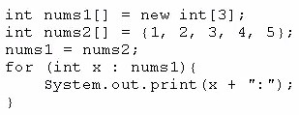

What is the result?

**A.** 1:2:3:4:5:

**B.** 1:2:3:

1. Compilation fails.
2. An ArrayoutofBoundsException is thrown at runtime.

# Answer: A

**Question No : 102**

Given:

Oracle 1z0-808 : Practice Tes



t

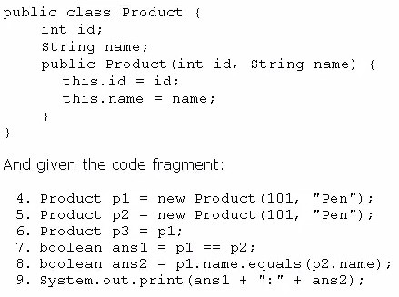

What is the result?

1. true:true
2. true:false
3. false:true
4. false:false

# Answer: C

**Question No : 103**

Given the code fragments:

Oracle 1z0-808 : Practice Tes



t

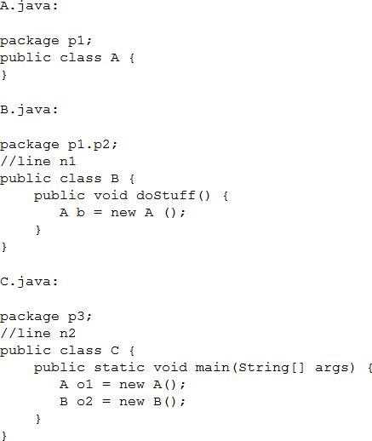

Which modification enables the code to compile?

1. Replace line n1 with: import p1.A;Replace line n2 with: import p1.A;import p1.p2.B;
2. Replace line n1 with: import p1;Replace line n2 with: import p1;import p1.p2;
3. Replace line n1 with: import p1.A;Replace line n2 with: import p1.*;
4. Replace line n1 with: import p1.*;Replace line n2 with: import p1.p2.*;

# Answer: A

**Question No : 104**

Which three are advantages of the Java exception mechanism?

 Oracle 1z0-808 : Practice Test

1. Improves the program structure because the error handling code is separated from the normal program function
2. Provides a set of standard exceptions that covers all the possible errors
3. Improves the program structure because the programmer can choose where to handle exceptions
4. Improves the program structure because exceptions must be handled in the method in which they occurred
5. Allows the creation of new exceptions that are tailored to the particular program being created

**Answer: A, C, E Explanation:** References:

**Question No : 105**

Given:

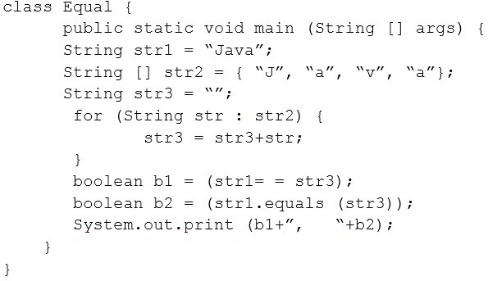

What is the result?

1. false, false
2. false, true
3. true, false
4. true, true



t

**Question No : 106**

Oracle 1z0-808 : Practice Tes

# Answer: B

Which code fragment causes a compilation error?

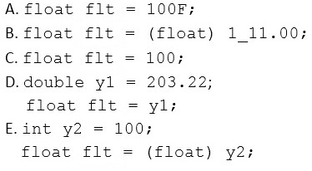

1. Option A
2. Option B
3. Option C
4. Option D
5. Option E

# Answer: D

**Question No : 107**

Given the code fragment:

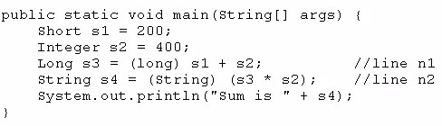

Oracle 1z0-808 : Practice Tes What is the result?



t

1. Sum is 600
2. Compilation fails at line n1.
3. Compilation fails at line n2.
4. A ClassCastException is thrown at line n1.
5. A ClassCastException is thrown at line n2.

# Answer: C

**Question No : 108**

Given the code fragment:

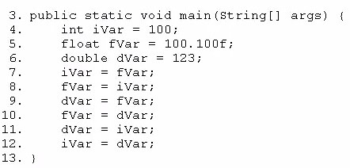

Which three lines fail to compile?

1. Line 7
2. Line 8
3. Line 9
4. Line 10
5. Line 11
6. Line 12

# Answer: A,D,F

**Question No : 109**

Oracle 1z0-808 : Practice Tes Given the code fragment:



t

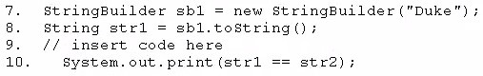

Which code fragment, when inserted at line 9, enables the code to print true?

1. String str2 = str1;
2. String str2 = new String (str1);
3. String str2 = sb1. toString ();
4. String str2 = "Duke";

# Answer: A

**Question No : 110**

Which two statements are true?

1. Error class is unextendable.
2. Error class is extendable.
3. Error is a RuntimeException.
4. Error is an Exception.
5. Error is a Throwable.

# Answer: B,E

**Question No : 111**

Given the code fragment:

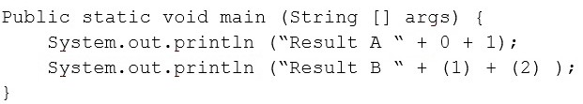

Oracle 1z0-808 : Practice Tes What is the result?



t

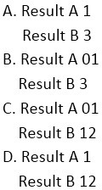

1. Option A
2. Option B
3. Option C
4. Option D

# Answer: C

**Question No : 112**

Given the code fragment:

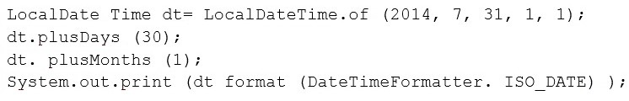

What is the result?

**A.** An exception is thrown at runtime.

**B.** 07-31-2014

 Oracle 1z0-808 : Practice Test

**C.** 2014-07-31

**D.** 2014-09-30

# Answer: C

# When dt is modified it should be stored like

# dt = dt.plusDays(xx);

**Question No : 113**

What is the name of the Java concept that uses access modifiers to protect variables and hide them within a class?

1. Encapsulation
2. Inheritance
3. Abstraction
4. Instantiation
5. Polymorphism

# Answer: A Explanation:

Using the private modifier is the main way that an object encapsulates itself and hide data from the outside world.

References:

**Question No : 114**

Given the code fragment:

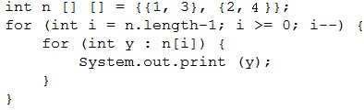

What is the result?



t

**Question No : 115**

Oracle 1z0-808 : Practice Tes

**A.** 1324

**B.** 2413

**C.** 3142

**D.** 4231

# Answer: B

Given:

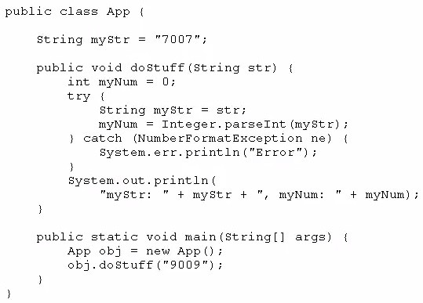

What is the result?

1. myStr: 9009, myNum: 9009
2. myStr: 7007, myNum: 7007
3. myStr: 7007, myNum: 9009
4. Compilation fails

# Answer: C

**Question No : 116**

Oracle 1z0-808 : Practice Tes Given:



t

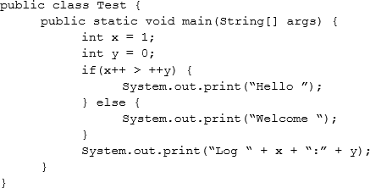

What is the result?

1. Hello Log 1:0
2. Hello Log 2:1
3. Welcome Log 2:1
4. Welcome Log 1:0

# Answer: C

**Question No : 117**

Given the code fragment:

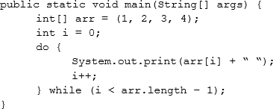



t

**Question No : 118**

Oracle 1z0-808 : Practice Tes What is the result?

**A.** 1 2 3 4followed by an ArrayIndexOutOfBoundsException

**B.** 1 2 3

**C.** 1 2 3 4

**D.** Compilation fails.

# Answer: B

Given the code fragment:

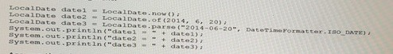

Assume that the system date is June 20, 2014. What is the result?

1. Compilation fails.
2. A DateParseExcpetion is thrown at runtime.

**C.** Date1 = 2014-06-20 Date2 = 2014-06-20

Date3 = 2014-06-20

**D.** date1 = 06/20/2014 date2 = 2014-06-20

date3 = Jun 20, 2014

# Answer: C

**Question No : 119**

Given the code fragment:

Oracle 1z0-808 : Practice Tes



t

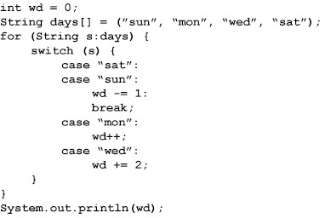

What is the result?

1. 3
2. 4
3. -1
4. Compilation fails.

# Answer: A

**Question No : 120**

Given the code fragment:

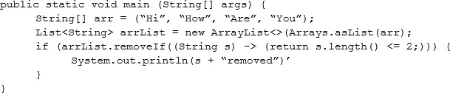

What is the result?



t

**Question No : 121**

Oracle 1z0-808 : Practice Tes

1. Compilation fails.
2. Hi removed
3. An UnsupportedOperationException is thrown at runtime.
4. The program compiles, but it prints nothing.

# Answer: A

Given the code fragment:

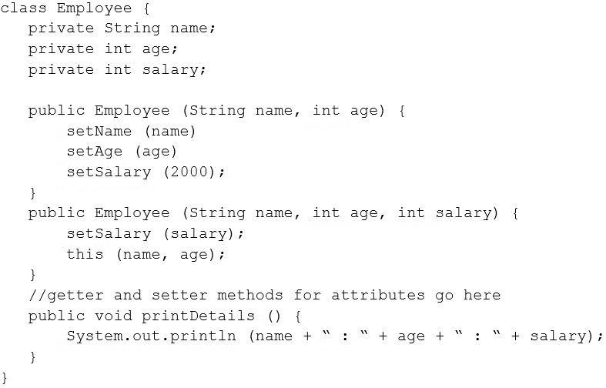

Test.java

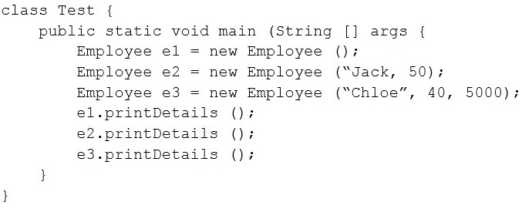

Oracle 1z0-808 : Practice Tes Which is the result?



t

**A.** Compilation fails in the Employee class.

**B.** null : 0: 0Jack : 50 : 0Chloe : 40 : 5000

**C.** null : 0 : 0Jack : 50 : 2000Chloe : 40 : 5000

1. Compilation fails in the Test class.
2. Both the Employee class and the test class fail to compile.

# Answer: E

**Question No : 122**

Given:

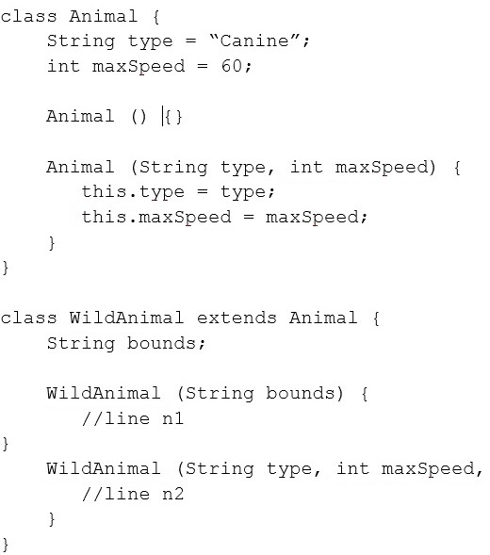

Oracle 1z0-808 : Practice Tes And given the code fragment:



t

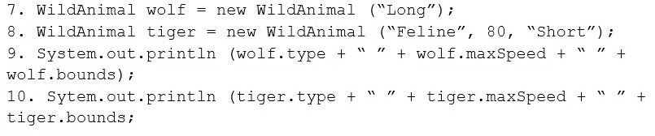

Which two modifications enable the code to print the following output? Canine 60 Long

Feline 80 Short

1. Replace line n1 with:super ();this.bounds = bounds;
2. Replace line n1 with:this.bounds = bounds;super ();
3. Replace line n2 with:super (type, maxSpeed);this (bounds);
4. Replace line n1 with:this (“Canine”, 60);this.bounds = bounds
5. Replace line n2 with:super (type, maxSpeed);this.bounds = bounds;

# Answer: A, E

**Question No : 123**

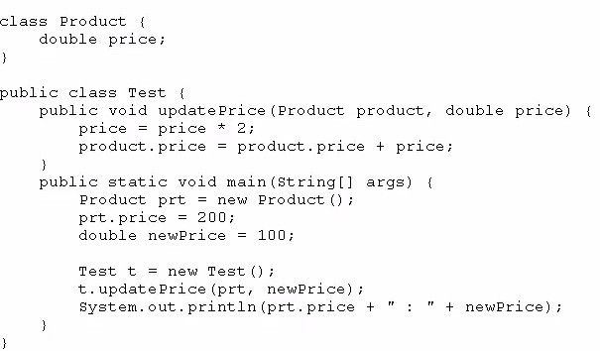Given:



t

**Question No : 124**

Oracle 1z0-808 : Practice Tes What is the result?

**A.** 200.0 : 100.0

**B.** 400.0 : 200.0

**C.** 400.0 : 100.0

**D.** Compilation fails.

# Answer: C

Which statement is true about the switch statement?

1. It must contain the default section.
2. The break statement, at the end of each case block, is mandatory.
3. Its case label literals can be changed at runtime.
4. Its expression must evaluate to a single value.

# Answer: D

**Explanation:** References:

**Question No : 125**

Given the following code for the classes MyException and Test:

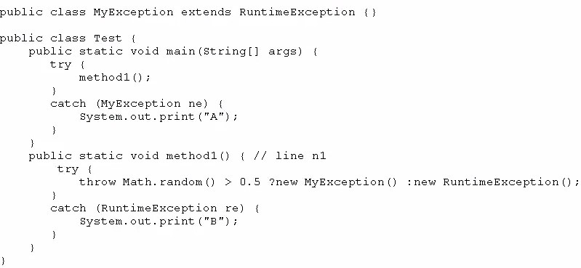

Oracle 1z0-808 : Practice Tes What is the result?



t

1. A
2. B
3. Either A or B
4. A B
5. A compile time error occurs at line n1

# Answer: B

**Question No : 126**

Given the code fragment:

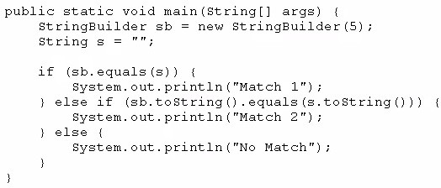

What is the result?

1. Match 1
2. Match 2
3. No Match
4. A NullPointerException is thrown at runtime.

# Answer: B

**Question No : 127**

Which three statements are true about the structure of a Java class?



t

**Question No : 128**

Oracle 1z0-808 : Practice Tes

1. A public class must have a main method.
2. A class can have only one private constructor.
3. A method can have the same name as a field.
4. A class can have overloaded static methods.
5. The methods are mandatory components of a class.
6. The fields need not be initialized before use.

# Answer: C, D, F

Given the code fragment:

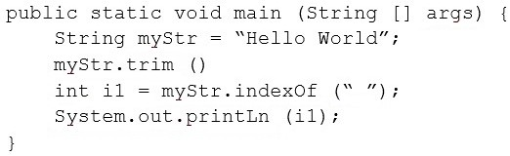

What is the result?

1. An exception is thrown at runtime.
2. -1
3. 5
4. 0

# Answer: C

**Question No : 129**

Given the code fragment:

 Oracle 1z0-808 : Practice Test

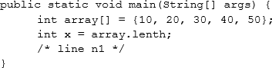

Which two code fragments can be independently inserted at line n1 to enable the code to print the elements of the array in reverse order?

1. while (x > 0) {x--;System.out.print(array[x]);}
2. do {x--;System.out.print(array[x]);} while (x >= 0);
3. while (x >= 0) {System.out.print(array[x]);x--;}
4. do {System.out.print(array[x]);--x;} while (x >= 0);
5. while (x > 0) {System.out.print(array[--x]);}

# Answer: A, E

**Question No : 130**

Given:

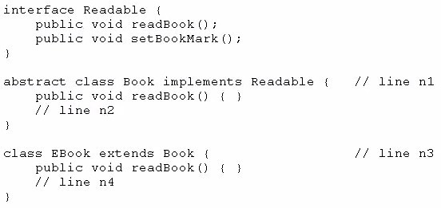

And given the code fragment:

Book book1 = new EBook (); Book1.readBook();

Oracle 1z0-808 : Practice Tes Which option enables the code to compile?



t

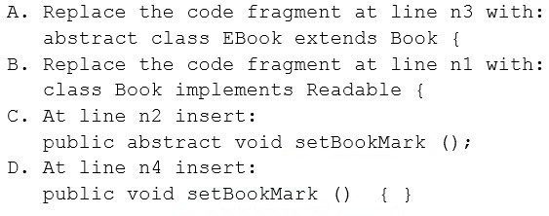

1. Option A
2. Option B
3. Option C
4. Option D

# Answer: A, D

**Question No : 131**

Given the code fragment:

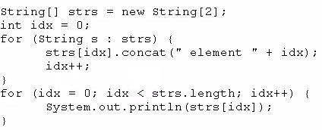

What is the result?

1. Element 0Element 1
2. Null element 0Null element 1



t

**Question No : 132**

Oracle 1z0-808 : Practice Tes

1. NullNull
2. A NullPointerException is thrown at runtime.

# Answer: D

Given:

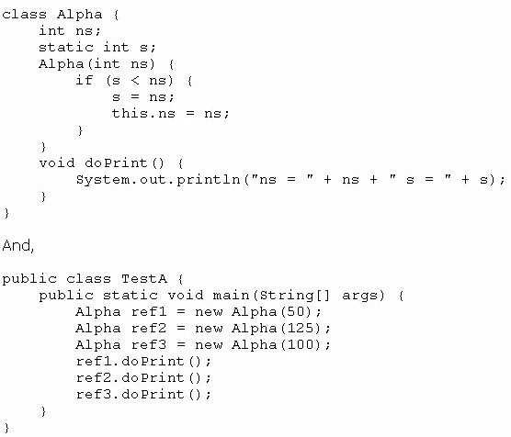

What is the result?

Oracle 1z0-808 : Practice Tes



t

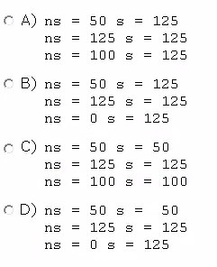

1. Option A
2. Option B
3. Option C
4. Option D

# Answer: B

**Question No : 133**

Which statement will empty the contents of a StringBuilder variable named sb?

1. sb. deleteAll ();
2. sb. delete (0, sb. size () );
3. sb. delete (0, sb. length () );
4. sb. removeAll ();

# Answer: C

**Question No : 134**

Oracle 1z0-808 : Practice Tes Given:



t

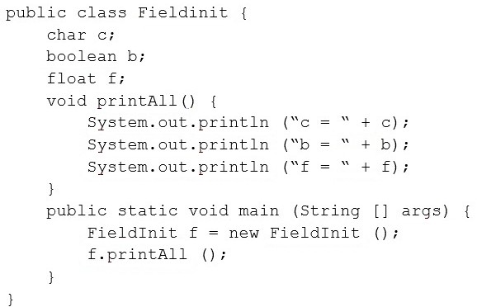

What is the result?

1. c=b = falsef = 0.0
2. c= nullb = truef = 0.0
3. c=0b = falsef = 0.0f
4. c= nullb = falsef = 0.0F

# Answer: A

**Question No : 135**

Given the code fragment:

Oracle 1z0-808 : Practice Tes



t

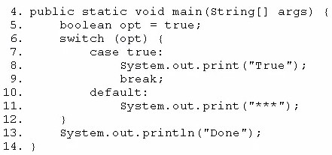

Which modification enables the code fragment to print TrueDone?

1. Replace line 5 With String opt= "true";Replace line 7 with case "true":
2. Replace line 5 with boolean opt = l;Replace line 7 with case 1=
3. At line 9, remove the break statement.
4. Remove the default section.

# Answer: A

**Question No : 136**

Given the code fragment:

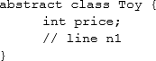

Which three code fragments are valid at line n1?

1. public static void insertToy() {/* code goes here */}
2. public abstract Toy getToy() {return new Toy();}
3. public void printToy();
4. public int calculatePrice() {return price;}
5. public abstract int computeDiscount();

# Answer: A, D, E



t

**Question No : 137**

Oracle 1z0-808 : Practice Tes

Given the code fragment:

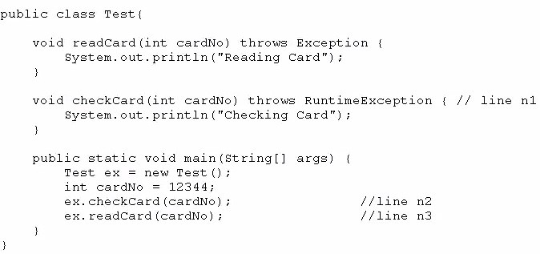

What is the result?

1. Reading CardChecking Card
2. Compilation fails only at line n1.
3. Compilation fails only at line n2.
4. Compilation fails only at line n3.
5. Compilation fails at both line n2 and line n3.

# Answer: D

**Question No : 138**

Given the code fragment:





t

**Question No : 139**

Oracle 1z0-808 : Practice Tes What is the result if the integer aVar is 9?

1. Compilation fails.
2. 10 Hello Universe!
3. 10 Hello World!
4. 9 Hello World!

# Answer: C

Given the code fragment:

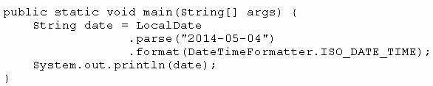

What is the result?

**A.** May 04, 2014T00:00:00.000 **B.** 2014-05-04T00:00: 00. 000 **C.** 5/4/14T00:00:00.000

**D.** An exception is thrown at runtime.

# Answer: D

**Question No : 140**

Given the code fragment:

Oracle 1z0-808 : Practice Tes



t

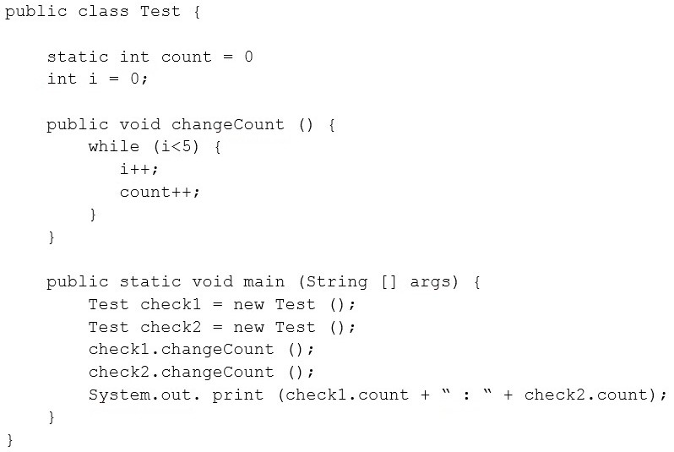

What is the result?

**A.** 5 : 5

**B.** 10 : 10

**C.** 5 : 10

**D.** Compilation fails.

# Answer: B

**Explanation:** References:

**Question No : 141**

Given the code fragment:

Oracle 1z0-808 : Practice Tes



t

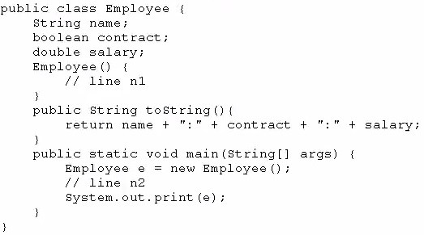

Which two modifications, when made independently, enable the code to print joe:true: 100.0?

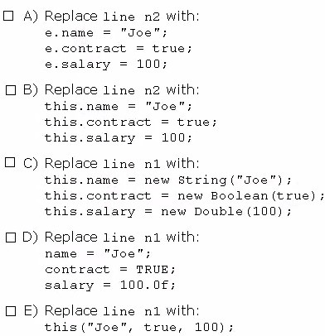



t

**Question No : 142**

Oracle 1z0-808 : Practice Tes

1. Option A
2. Option B
3. Option C
4. Option D
5. Option E

# Answer: A,C

Given the code fragment:

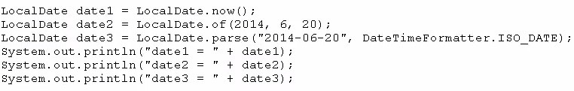

Assume that the system date is June 20, 2014. What is the result?

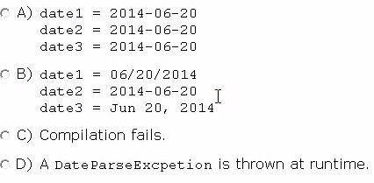

1. Option A
2. Option B
3. Option C
4. Option D

# Answer: A



Oracle 1z0-808 : Practice Test

Given the content of three files:

**Question No : 143**

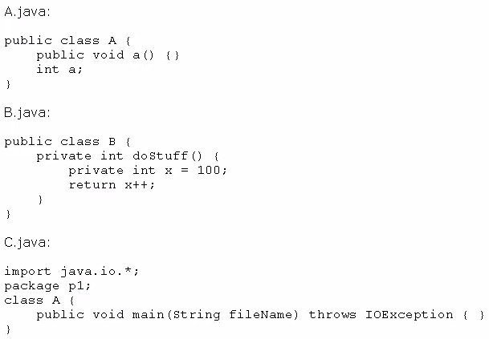

Which statement is true?

1. Only the A.Java file compiles successfully.
2. Only the B.java file compiles successfully.
3. Only the C.java file compiles successfully.
4. The A.Java and B.java files compile successfully.
5. The B.java and C.java files compile successfully.
6. The A.Java and C.java files compile successfully.

# Answer: A

**Question No : 144**

Given the code fragment:

Oracle 1z0-808 : Practice Test

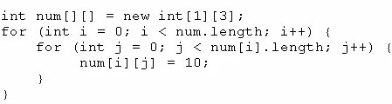

Which option represents the state of the num array after successful completion of the outer loop?

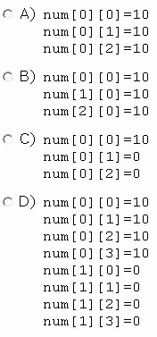

1. Option A
2. Option B
3. Option C
4. Option D

# Answer: A

Oracle 1z0-808 : Practice Tes



t